UNITED STATES

SECURITIES AND EXCHANGE COMMISSION

Washington, D.C. 20549

__________

Form 8-K/A

(Amendment No.2)
CURRENT REPORT

Pursuant to Section 13 or 15(d) of The Securities Exchange Act of 1934

Date of Report (Date of earliest event reported) April 7, 2026

AquaBounty Technologies, Inc.

(Exact name of registrant as specified in its charter)

Delaware | 001-36426 | 04-3156167
(State or other jurisdiction | (Commission | (IRS Employer
of‎ incorporation) | ‎File Number) | Identification‎ | No.)

233 Ayer Road, Suite 4, Harvard, Massachusetts

(Address of principal executive offices)

01451

(Zip Code)

978-648-6000

(Registrant’s telephone number, including area code)

(Former name or former address, if changed since last report.)

Check the appropriate box below if the Form 8-K filing is intended to simultaneously satisfy the filing obligation of the registrant under any of the following provisions:

- Written communications pursuant to Rule 425 under the Securities Act (17 CFR 230.425)

- Soliciting material pursuant to Rule 14a-12 under the Exchange Act (17 CFR 240.14a-12)
- Pre-commencement communications pursuant to Rule 14d-2(b) under the Exchange Act (17 CFR 240.14d-2(b))
- Pre-commencement communications pursuant to Rule 13e-4(c) under the Exchange Act (17 CFR 240.13e-4(c))

Securities registered pursuant to Section 12(b) of the Act:
Title of each class | Trading Symbol(s) | Name of exchange on which registered
Common Stock, par value $0.001 per share | AQB | The NASDAQ Stock Market LLC
Indicate by check mark whether the registrant is an emerging growth company as defined in Rule 405 of the Securities Act of 1933 (§230.405 of this chapter) or Rule 12b-2 of the Securities Exchange Act of 1934 (§240.12b-2 of this chapter).

Emerging growth company o

If an emerging growth company, indicate by check mark if the registrant has elected not to use the extended transition period for complying with any new or revised financial accounting standards provided pursuant to Section 13(a) of the Exchange Act. o

Explanatory Note

AquaBounty Technologies, Inc. (the “Company”) is filing this Amendment No. 2 to the Current Report on Form 8-K filed with the Securities and Exchange Commission on April 8, 2026 (the “Original Report”) solely to report the filing of a Certificate of Correction to the Certificate of Designations of the Company’s Series A Convertible Preferred Stock and to amend the disclosure under Item 3.03 of the Original Report accordingly. Except as expressly set forth herein, this Amendment No. 2 does not amend, update or restate any other information in the Original Report. Terms capitalized but not otherwise defined herein shall have the meanings ascribed to them in the Original Report.

Item 3.03. Material Modification to Rights of Security Holders.

As previously reported in the Original Report, on April 7, 2026, the Company filed a Certificate of Designations of Series A Convertible Preferred Stock (the “Certificate of Designations”) with the Secretary of State of the State of Delaware.

On April 16, 2026, the Company filed a Certificate of Correction to the Certificate of Designations (the “Certificate of Correction”) with the Secretary of State of the State of Delaware pursuant to Section 103 of the Delaware General Corporation Law. The Certificate of Correction corrects a scrivener’s error in Section 8.1(a) of the Certificate of Designations relating to the initial conversion price of the Series A Convertible Preferred Stock.

As corrected, the initial conversion price per share of the Series A Convertible Preferred Stock is $0.9129, subject to adjustment as provided in the
Certificate of Designations. The Certificate of Designations previously stated that the initial conversion price was equal to the Liquidation Value of
$18.2580 per share. The Company confirms that no other terms, rights, preferences, privileges or limitations of the Series A Convertible Preferred Stock
were modified, amended or affected by the Certificate of Correction.

The following is a summary of the material terms of the Series A Preferred Stock, as corrected by the Certificate of Correction:

Ranking. The Series A Preferred Stock ranks senior to the Company’s common stock and all other junior equity securities with respect to dividends and distributions upon liquidation, dissolution or winding up.

Dividends. Dividends will accrue on each share of Series A Preferred Stock at the rate of 18.0% per annum on a quarterly basis in arrears, calculated solely on the Liquidation Value (as defined below). Dividends are payable in cash when declared on a bi-annual schedule (the last day of October and April), and the Board may permit dividends to accumulate rather than be paid on a Dividend Payment Date, subject to applicable law and exchange rules. No dividends (including accrued or accumulated dividends) may be payable or settleable in shares of common stock unless such issuance is permitted under applicable exchange rules.

Partial dividend payments. If the Company pays less than the full amount of accrued and accumulated dividends, the amount paid must be distributed pro rata among holders based on the accrued and accumulated but unpaid dividends on the shares held by each holder.

Liquidation preference / Change of Control. Upon any liquidation, dissolution or winding up, holders of Seres A Preferred Stock are entitled to receive, before any distribution to junior securities, at the holder’s election, either (i) cash or (ii) non-cash consideration valued at fair market value as determined by the board in good faith, in each case equal to the aggregate Liquidation Value plus all unpaid accrued and accumulated dividends (whether or not declared). A change of control is treated as a liquidation and triggers the same preference. The Series A Preferred Stock is non-participating.

Liquidation Value. The Liquidation Value per share is $18.2580, subject to adjustment for stock splits, stock dividends, recapitalizations and similar transactions affecting the Series A Preferred Stock.

Voting. Each share of Series A Preferred Stock votes together with the Common Stock as a single class on all matters submitted to stockholders, with each share having a number of votes equal to the number of shares of common stock into which it is then convertible (as of the applicable record date).

Protective provisions. Without the prior written consent of holders of at least two-thirds of the outstanding Series A Preferred Stock voting as a separate class, the Company may not, among other things, authorize any security senior to the Series A Preferred Stock, make certain charter/bylaw/Series A Preferred Stock amendments, or redeem/repurchase or pay dividends/distributions on capital stock, subject to the exceptions stated in the Certificate of Designations.

Conversion. Shares of Series A Preferred Stock are convertible at any time at the holder’s election into shares of common stock based on the conversion price per share, which is initially $0.9129 (the “Conversion Price”). In addition, subject to compliance with applicable exchange rules, the Company’s Board of Directors may elect to defer payment of dividends on the Series A Preferred Stock, and such accrued and unpaid dividends may be converted into shares of common stock based on the applicable Conversion Price.

Redemption. After the closing of a debt or equity financing resulting in proceeds to the Company in excess of $20,000,000, holders representing at least a two-thirds “Supermajority Interest” may require the Company to redeem all (but not less than all) outstanding shares for a per-share price equal to the applicable Liquidation Value plus all unpaid accrued and accumulated dividends (whether or not declared), subject to legally available funds. The redemption must occur within 90 days after the Company receives the election notice, and each holder may instead elect to convert its shares before the conversion election deadline specified in the redemption notice.

Insufficient funds / nonpayment. If the Company lacks legally available funds on the redemption date, it must redeem the maximum number of shares it can redeem pro rata among holders and use later-available funds to redeem the remainder. If the Company does not pay the full redemption price when due, the unpaid amount bears interest at 18.0% per annum, and the unredeemed shares remain outstanding with continuing rights as provided in the Certificate of Designations.

Breach remedies. Specified events constitute a “Series A Preferred Stock Breach,” including failure to pay dividends when due, failure to make redemption or liquidation payments when due, breach of the protective provisions, and certain bankruptcy/insolvency events. During a continuing breach, the dividend rate increases by 3.0% per annum until cured, and upon certain bankruptcy/insolvency events all outstanding shares become subject to automatic redemption for the Series A redemption price to the extent permitted by law.

The foregoing description of the Certificate of Designations, as corrected by the Certificate of Correction, does not purport to be complete and is qualified in its entirety by reference to the Certificate of Designations, as corrected by the Certificate of Correction, which is filed as Exhibit 3.1 to this Form 8-K/A and is incorporated herein by reference.

Item 5.03. Amendments to Articles of Incorporation or Bylaws; Change in Fiscal Year.

The disclosure set forth under Item 3.03 above is incorporated herein by reference.

Item 9.01. Financial Statements and Exhibits.

(d) Exhibits.

3.1 Certificate of Designations of Series A Convertible Preferred Stock of AquaBounty Technologies, Inc., as corrected by the Certificate of Correction dated April 16, 2026.
104 Cover Page Interactive Data File (the cover page XBRL tags are embedded in the Inline XBRL document).

SIGNATURES

Pursuant to the requirements of the Securities Exchange Act of 1934, the registrant has duly caused this report to be signed on its behalf by the undersigned hereunto duly authorized.

AquaBounty Technologies, Inc.
(Registrant)

Date: April 16, 2026 /s/ David A. Frank David A. Frank
Interim Chief Executive Officer, Chief

Financial Officer and Treasurer

Exhibit 3.1
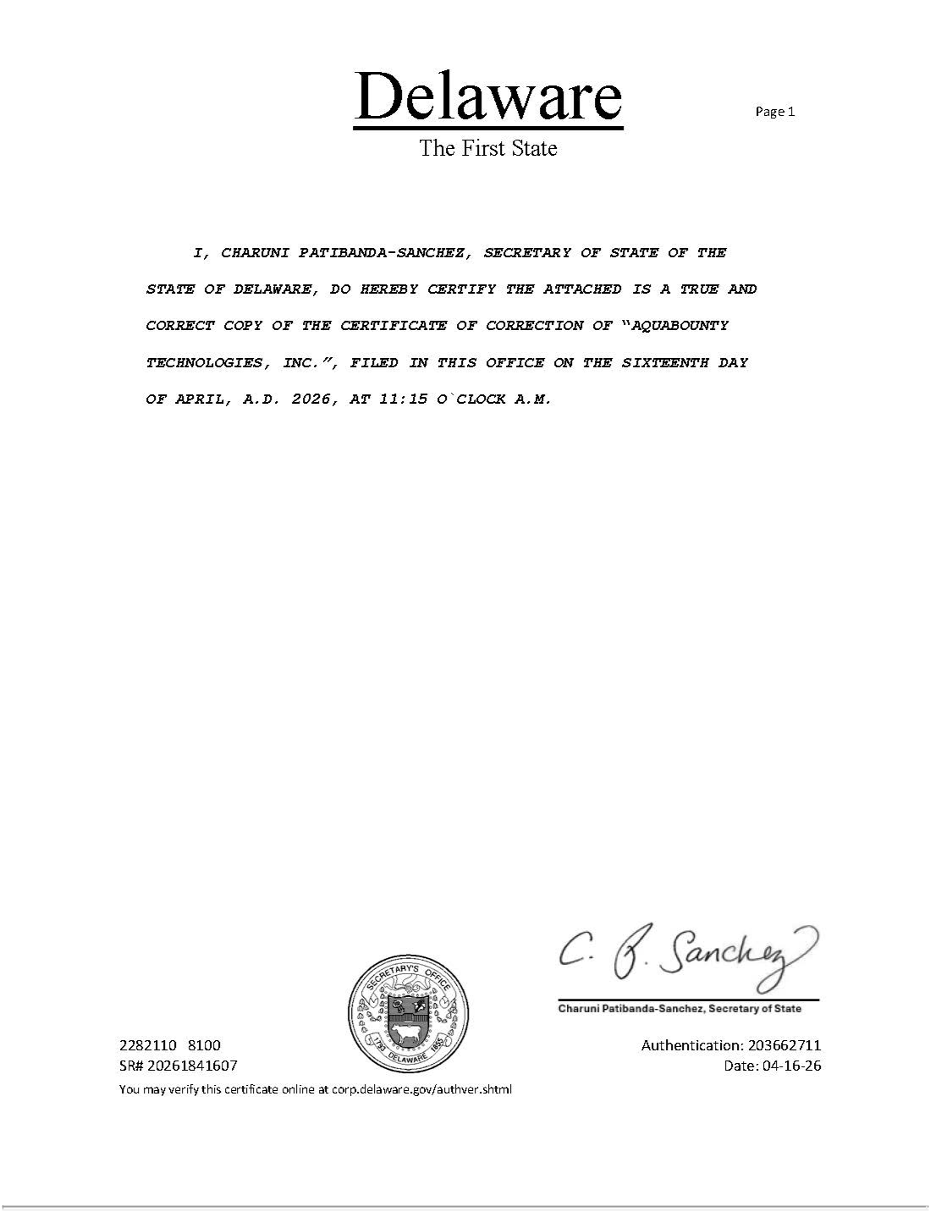

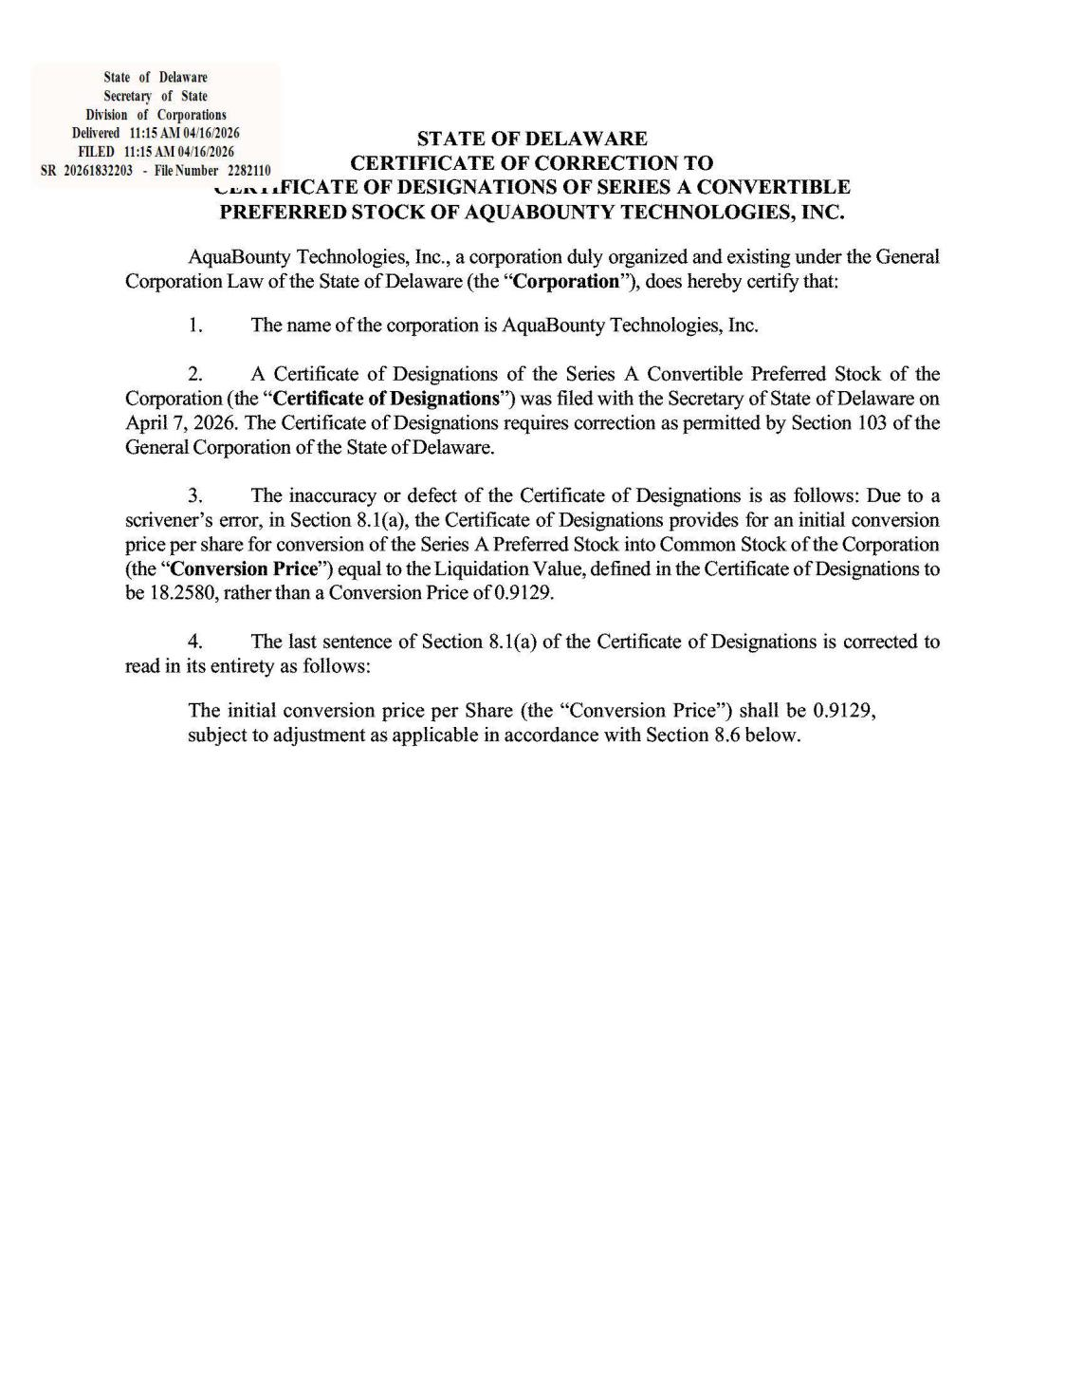

2

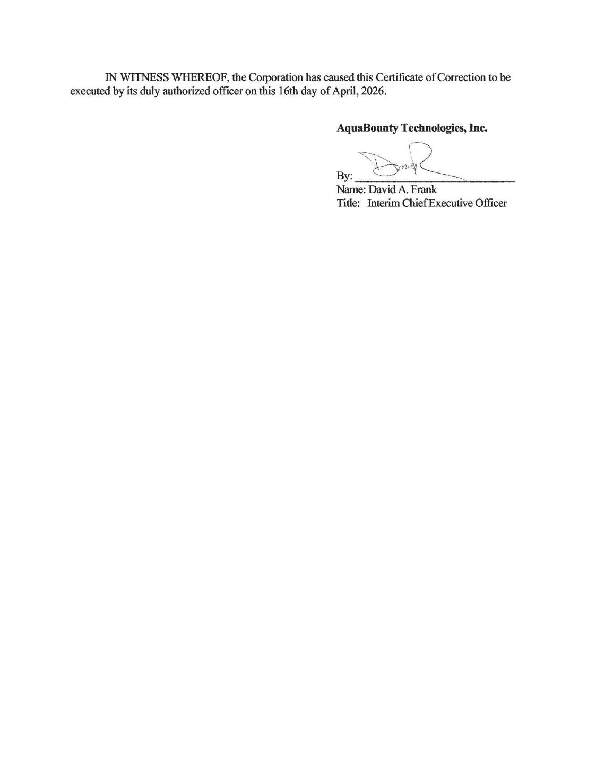

3

Certificate of Designations of Series A Convertible Preferred Stock of AquaBounty Technologies, Inc.

Pursuant to Section 151 of the General Corporation Law of the State of Delaware, AquaBounty Technologies, Inc., a corporation organized and existing under the General Corporation Law of the State of Delaware (the “Corporation”), in accordance with the provisions of Section 103 thereof, does hereby submit the following:

WHEREAS, the Certificate of Incorporation of the Corporation (the “Certificate of Incorporation”) authorizes the issuance of up to 5,000,000 shares of preferred stock, par value $0.01 per share, of the Corporation (“Preferred Stock”) in one or more series, and expressly authorizes the Board of Directors of the Corporation (the “Board”), subject to limitations prescribed by law, to provide, out of the unissued shares of Preferred Stock, for series of Preferred Stock, and, with respect to each such series, to establish and fix the number of shares to be included in any series of Preferred Stock and the designation, rights, preferences, powers, restrictions, and limitations of the shares of such series; and

WHEREAS it is the desire of the Board to establish and fix the number of shares to be included in a new series of Preferred Stock and the designation, rights, preferences, and limitations of the shares of such new series.

NOW, THEREFORE, BE IT RESOLVED, that the Board does hereby provide for the issue of a series of Preferred Stock and does hereby in this Certificate of Designation (the “Certificate of Designation”) establish and fix and herein state and express the designation, rights, preferences, powers, restrictions, and limitations of such series of Preferred Stock as follows:

- Designation. There shall be a series of Preferred Stock that shall be designated as “Series A Convertible Preferred Stock” (the “Series A Preferred Stock”) and the number of Shares constituting such series shall be 400,000. The rights, preferences, powers, restrictions, and limitations of the Series A Preferred Stock shall be as set forth herein.

- Defined Terms. For purposes hereof, the following terms shall have the following

meanings:

“Board” has the meaning set forth in the Recitals.

“Certificate of Designation” has the meaning set forth in the Recitals.

“Certificate of Incorporation” has the meaning set forth in the Recitals.

“Change of Control” means any transaction by which another Person acquires Common Stock or any merger, consolidation, recapitalization, or reorganization of the Corporation with or into another Person (whether or not the Corporation is the surviving corporation), in each case that results in the inability of the holders of Common Stock (or other voting stock of the Corporation) immediately prior to such stock transaction, merger, consolidation, recapitalization, or reorganization to designate or elect any members of the board of directors (or its equivalent) of the resulting entity or its parent company.

“Common Stock” means the common stock, par value $0.001 per share, of the

Corporation.

“Common Stock Deemed Outstanding” means, at any given time, the sum of

- the number of shares of Common Stock actually outstanding at such time, plus (b) the number of shares of Common Stock issuable upon exercise of Options actually outstanding at such time, plus (c) the number of shares of Common Stock issuable upon conversion or exchange of Convertible Securities actually outstanding at such time (treating as actually outstanding any Convertible Securities issuable upon exercise of Options actually outstanding at such time), in each case, regardless of whether the Options or Convertible Securities are actually exercisable at such time; provided, that Common Stock Deemed Outstanding at any given time shall not include shares owned or held by or for the account of the Corporation or any of its wholly owned Subsidiaries.

“Convertible Securities” means any securities (directly or indirectly) convertible into or exchangeable for Common Stock, but excluding Options.

“Corporation” has the meaning set forth in the Preamble.

“Conversion Price” has the meaning set forth in Section 8.1(a).

“Conversion Shares” means the shares of Common Stock issuable upon conversion of the Series A Preferred Stock in accordance with the terms of Section 8.

“Date of Issuance” means, for any Share of Series A Preferred Stock, the date on which the Corporation initially issues such Share (without regard to any subsequent transfer of such Share or reissuance of the certificate(s) representing such Share).

“Deemed Liquidation” has the meaning set forth in Section 5.1(b) “Dividend Payment Date” has the meaning set forth in Section 4.1.

“Junior Securities” means, collectively, the Common Stock and any other class of equity securities of the Corporation.

“Liquidation” has the meaning set forth in Section 5.1(a).

“Liquidation Value” means, with respect to any Share on any given date, $18.2580 (as adjusted for any stock splits, stock dividends, recapitalizations, or similar transaction with respect to the Series A Preferred Stock).

“Options” means any warrants or other rights or options to subscribe for or purchase Common Stock or Convertible Securities.

“Person” means an individual, corporation, partnership, joint venture, limited liability company, governmental authority, unincorporated organization, trust, association, or other entity.

2

“Preferred Stock” has the meaning set forth in the Recitals.

“Securities Act” means the Securities Act of 1933, as amended, or any successor federal statute, and the rules and regulations thereunder, which shall be in effect at the time.

“Series A Conversion Election Date” has the meaning set forth in Section 7.2.

“Series A Election Notice” has the meaning set forth in Section 7.1.

“Series A Preferred Stock” has the meaning set forth in Section 1.

“Series A Preferred Stock Breach” has the meaning set forth in Section 9.1.

“Series A Redemption” has the meaning set forth in Section 7.1.

“Series A Redemption Date” has the meaning set forth in Section 7.2.

“Series A Redemption Notice” has the meaning set forth in Section 7.2.

“Series A Redemption Price” has the meaning set forth in Section 7.1.

“Share” means a share of Series A Preferred Stock.

“Subsidiary” means, with respect to any Person, any other Person of which a majority of the outstanding shares or other equity interests having the power to vote for directors or comparable managers are owned, directly or indirectly, by the first Person.

“Supermajority Interest” has the meaning set forth in Section 6.2.

- Rank. With respect to payment of dividends and distribution of assets upon liquidation, dissolution, or winding up of the Corporation, whether voluntary or involuntary, all Shares of the Series A Preferred Stock shall rank senior to all Junior Securities.

- Dividends.

4.1 Accrual and Payment of Dividends. From and after the Date of Issuance of any Share, cumulative dividends on such Share shall accrue, whether or not declared by the Board and whether or not there are funds legally available for the payment of dividends, on a quarterly basis in arrears at the rate of 18.0% per annum, calculated solely on the Liquidation Value of such Share and not on any unpaid accrued or accumulated dividends. All accrued dividends on any Share shall be paid in cash when declared by the Board out of funds legally available therefor on a bi-annual basis the last day of October and April of each calendar year (each such date, a “Dividend Payment Date”); provided, that the Board may, in its reasonable discretion and to the extent in compliance with applicable law and applicable rules of a securities exchange, determine that all accrued dividends on any Share shall accumulate on the applicable Dividend Payment Date and remain accumulated dividends until paid pursuant hereto or converted pursuant to Section 8. All accrued and accumulated dividends on the

3

Shares shall be prior and in preference to any dividend on any Junior Securities and shall be fully declared and paid before any dividends are declared and paid, or any other distributions or redemptions are made, on any Junior Securities. Notwithstanding anything herein to the contrary, no dividends (including accrued or accumulated dividends) shall be payable or settleable in shares of Common Stock unless such issuance of shares is in accordance with and permitted under Nasdaq Listing Rule 5635(d) without stockholder approval (or stockholder approval has been obtained).

4.2 Partial Dividend Payments. Except as otherwise provided herein, if at any time the Corporation pays less than the total amount of dividends then accrued and accumulated with respect to the Series A Preferred Stock, such payment shall be distributed pro rata among the holders thereof based upon the aggregate accrued and accumulated but unpaid dividends on the Shares held by each such holder.

- Liquidation.

5.1 Liquidation; Deemed Liquidation.

  - Liquidation. In the event of any voluntary or involuntary liquidation, dissolution or winding up of the Corporation (collectively with a Deemed Liquidation, a “Liquidation”), the holders of Shares of Series A Preferred Stock then outstanding shall be entitled to be paid out of the assets of the Corporation available for distribution to its stockholders, before any payment shall be made to the holders of Junior Securities by reason of their ownership thereof, at each such holder’s election, (i) an amount in cash or

- non-cash consideration at a fair market value (to be determined by the Board in good

faith), in each case of clauses (i) and (ii), equal to the aggregate Liquidation Value of all Shares held by such holder, plus all unpaid accrued and accumulated dividends on all such Shares (whether or not declared). For the avoidance of doubt, the Series A Preferred Stock shall be non‑participating and shall not participate with holders of Common Stock in any distribution beyond the amounts expressly provided herein.

- Deemed Liquidation. The occurrence of a Change of Control (such event, a “Deemed Liquidation”) shall be deemed a Liquidation for purposes of this Section 5. Upon the consummation of any such Deemed Liquidation, the holders of the Series A Preferred Stock shall, in consideration for cancellation of their Shares, be entitled to the same rights such holders are entitled to under this Section 5 upon the occurrence of a Liquidation, including the right to receive the full preferential payment from the Corporation of the amounts payable with respect to the Series A Preferred Stock under Section 5.1(a) hereof.

5.2 Insufficient Assets. If upon any Liquidation the remaining assets of the Corporation available for distribution to its stockholders shall be insufficient to pay the holders of the Shares of Series A Preferred Stock the full preferential amount to which they are entitled under Section 5.1, (a) the holders of the Shares shall share ratably in any distribution of the remaining assets and funds of the Corporation in proportion to the respective full preferential amounts which would otherwise be payable in respect of the Series A Preferred Stock in the aggregate upon such Liquidation (or Deemed Liquidation) if all

4

amounts payable on or with respect to such Shares were paid in full, and (b) the Corporation shall not make or agree to make any payments to the holders of Junior Securities.

5.3 Notice. Notice Requirement. In the event of any Liquidation (or Deemed Liquidation), the Corporation shall, within ten (10) days of the date the Board approves such action, or no later than twenty (20) days of any stockholders’ meeting called to approve such action, or within twenty (20) days of the commencement of any involuntary proceeding, whichever is earlier, give each holder of Shares of Series A Preferred Stock written notice of the proposed action. Such written notice shall describe the material terms and conditions of such proposed action, including a description of the stock, cash, and property to be received by the holders of Shares upon consummation of the proposed action and the date of delivery thereof. If any material change in the facts set forth in the initial notice shall occur, the Corporation shall promptly give written notice to each holder of Shares of such material change.

- Voting.

6.1 Voting Generally. Each holder of outstanding Shares of Series A Preferred Stock shall be entitled to vote with holders of outstanding shares of Common Stock, voting together as a single class, with respect to any and all matters presented to the stockholders of the Corporation for their action or consideration (whether at a meeting of stockholders of the Corporation, by written action of stockholders in lieu of a meeting or otherwise), except as provided by law or by the provisions of Section 6.2 below. In any such vote, each Share of Series A Preferred Stock shall be entitled to a number of votes equal to the number of shares of Common Stock into which the Share is convertible pursuant to Section 8 herein as of the record date for such vote or written consent or, if there is no specified record date, as of the date of such vote or written consent. Each holder of outstanding Shares of Series A Preferred Stock shall be entitled to notice of all stockholder meetings (or requests for written consent) in accordance with the Corporation’s bylaws.

6.2 Other Special Voting Rights. Without the prior written consent of holders of not less than two-thirds of the then total outstanding Shares of Series A Preferred Stock (a “Supermajority Interest”), voting separately as a single class with one vote per Share, in person or by proxy, either in writing without a meeting or at an annual or a special meeting of such holders, and any other applicable stockholder approval requirements required by law, the Corporation shall not take any of the actions or transactions described in this Section 6.2 (any such action or transaction without such prior written consent being null and void ab initio and of no force or effect) as follows:

- create, or authorize the creation of, any additional class or series of capital stock of the Corporation (or any security convertible into or exercisable for any class or series of capital stock of the Corporation) that ranks superior to the Series A Preferred Stock in rights, preferences, or privileges (including with respect to dividends, liquidation, redemption, or voting);

- increase or decrease the number of authorized shares of any series of Preferred Stock or authorize the issuance of or issue any shares of Preferred Stock that

5

rank superior to the Series A Preferred Stock in rights, preferences, or privileges (including with respect to dividends, liquidation, redemption, or voting);

- other than as contemplated by this Certificate of Designation, amend, alter, modify, or repeal the Certificate of Incorporation, this Certificate of Designation, or the by-laws of the Corporation, including the amendment of the Certificate of Incorporation by the adoption or amendment of any Certificate of Designation or similar document (other than any adoption of a Certificate of Designation with respect to the issuance of any shares of Preferred Stock that do not rank superior to the Series A Preferred Stock in rights, preferences, or privileges (including with respect to dividends, liquidation, redemption, or voting));

- redeem, purchase, or otherwise acquire or pay or declare any dividend or other distribution on (or pay into or set aside for a sinking fund for any such purpose) any capital stock of the Corporation; provided, that this restriction shall not apply to the redemption or repurchase of or the payment of dividends on Shares of Series A Preferred Stock pursuant hereto or the redemption or repurchase of or the payment of dividends on shares of Preferred Stock that do not rank superior to the Series A Preferred Stock in rights, preferences, or privileges (including with respect to dividends, liquidation, redemption, or voting); or

- agree or commit to do any of the foregoing.

- Redemption.

7.1 Redemption. At any time on or after the date of the closing of a debt or equity financing that results in proceeds to the Corporation in excess of $20,000,000, the holders of not less than a Supermajority Interest shall have the right to elect to have, out of funds legally available therefor, all (but not less than all) of the then outstanding Shares of Series A Preferred Stock redeemed by the Corporation (a “Series A Redemption”) for a price per Share equal to the Liquidation Value for such Share, plus all unpaid accrued and accumulated dividends on such Share (whether or not declared) (the “Series A Redemption Price”). Any such Series A Redemption shall occur not more than ninety (90) days following receipt by the Corporation of a written election notice (the “Series A Election Notice”) from the holders of not less than a Supermajority Interest. Upon receipt of a Series A Election Notice, all holders of Series A Preferred Stock shall be deemed to have elected to have all of their Shares redeemed pursuant to this Section 7 and such election shall bind all holders of Series A Preferred Stock; provided, that notwithstanding anything to the contrary contained herein, each holder of Shares of Series A Preferred Stock shall have the right to elect prior to the Series A Conversion Election Date to give effect to the conversion rights contained in Section 8 instead of giving effect to the provisions contained in this Section 7 with respect to the Shares of Series A Preferred Stock held by such holder. In exchange for the surrender to the Corporation by the respective holders of Shares of Series A Preferred Stock of their certificate or certificates representing such Shares in accordance with Section 7.4 below, the aggregate Series A Redemption Price for all Shares held by each holder of Shares shall be payable in cash in immediately available funds to the respective holders of the Series A Preferred Stock on the applicable Series A Redemption Date.

6

7.2 Redemption Notice. As promptly as practicable, but in no event later than ten

- days, following receipt of a Series A Election Notice, the Corporation shall send written notice (the “Series A Redemption Notice”) of its receipt of a Series A Election Notice to each holder of record of Series A Preferred Stock. Each Series A Redemption Notice shall state:

  - the number of Shares of Series A Preferred Stock held by the holder that the Corporation shall redeem on the Series A Redemption Date specified in the Series A Redemption Notice;

  - the date of the closing of the redemption, which pursuant to Section 7.1 shall be no later than ninety (90) days following receipt by the Corporation of the Series A Election Notice (the applicable date, the “Series A Redemption Date”) and the Series A Redemption Price;

  - the date upon which the holder’s right to convert its Shares pursuant to Section 8 terminates, which date shall be no earlier than five (5) days before the Series A Redemption Date (the applicable date, the “Series A Conversion Election Date”); and

  - the manner and place designated for surrender by the holder to the Corporation of his, her or its certificate or certificates representing the Shares of Series A Preferred Stock to be redeemed.

7.3 Insufficient Funds; Remedies for Nonpayment.

- Insufficient Funds. If on any Series A Redemption Date, the assets of the Corporation legally available are insufficient to pay the full Series A Redemption Price for the total number of Shares elected to be redeemed pursuant to Section 7.1, the Corporation shall (i) take all reasonably appropriate action, as determined by the Board in its reasonable discretion, within its means to maximize the assets legally available for paying the Series A Redemption Price, (ii) redeem out of all such assets legally available therefor on the applicable Series A Redemption Date the maximum possible number of Shares that it can redeem on such date, pro rata among the holders of such Shares to be redeemed in proportion to the aggregate number of Shares elected to be redeemed by each such holder on the applicable Series A Redemption Date and (iii) following the applicable Series A Redemption Date, at any time and from time to time when additional assets of the Corporation become available to redeem the remaining Shares, the Corporation shall, to the extent reasonably practicable, immediately use such assets to pay the remaining balance of the aggregate applicable Series A Redemption Price.

- Remedies for Nonpayment. If on any Series A Redemption Date, all of the Shares elected to be redeemed pursuant to a Series A Election Notice are not redeemed in full by the Corporation by paying the entire Series A Redemption Price, until such Shares are fully redeemed and the aggregate Series A Redemption Price paid in full, (i) all of the unredeemed Shares shall remain outstanding and continue to have the rights, preferences, and privileges expressed herein, including the accrual and

7

accumulation of dividends thereon as provided in Section 4, (b) interest on the portion of the aggregate Series A Redemption Price applicable to the unredeemed Shares shall accrue daily in arrears at a rate equal to 18.0% per annum and, for the avoidance of doubt, there shall be no additional dividend accrual during such period, and (c) the holders of the unredeemed Shares shall have the remedies set forth in Section 9.2.

7.4 Surrender of Certificates. On or before the Series A Redemption Date, each holder of Shares of Series A Preferred Stock not otherwise electing prior to the Series A Conversion Election Date to convert its Shares pursuant to Section 8 shall surrender the certificate or certificates representing such Shares to the Corporation, in the manner and place designated in the Series A Redemption Notice, duly assigned or endorsed for transfer to the Corporation (or accompanied by duly executed stock powers relating thereto), or, in the event the certificate or certificates are lost, stolen or missing, shall deliver an affidavit of loss, in the manner and place designated in the Series A Redemption Notice. Each surrendered certificate shall be canceled and retired and the Corporation shall thereafter make payment of the applicable Series A Redemption Price by certified check or wire transfer to the holder of record of such certificate; provided, that if less than all the Shares represented by a surrendered certificate are redeemed, then a new stock certificate representing the unredeemed Shares shall be issued in the name of the applicable holder of record of canceled stock certificate.

7.5 Rights Subsequent to Redemption. If on the applicable Series A Redemption Date, the Series A Redemption Price is paid (or tendered for payment) for any of the Shares to be redeemed on such Series A Redemption Date, then on such date all rights of the holder in the Shares so redeemed and paid or tendered, including any rights to dividends on such Shares, shall cease, and such Shares shall no longer be deemed issued and outstanding.

- Conversion.

8.1 Right to Convert.

- Right to Convert. Subject to the provisions of this Section 8 and the authority of the Board to determine pay accrued dividends in cash as set forth in Section 4.1, at any time and from time to time on or after the Date of Issuance, any holder of Series A Preferred Stock shall have the right by written election to the Corporation to convert all or any portion of the outstanding Shares of Series A Preferred Stock (including any fraction of a Share) held by such holder along with the aggregate accrued or accumulated and unpaid dividends thereon into an aggregate number of shares of Common Stock (including any fraction of a share) as is determined by (i) multiplying the number of Shares (including any fraction of a Share) to be converted by the Liquidation Value thereof, (ii) adding to the result all accrued and accumulated and unpaid dividends on such Shares to be converted, and then (iii) dividing the result by the Conversion Price in effect immediately prior to such conversion. The initial conversion price per Share (the “Conversion Price”) shall be the Liquidation Value of such Share, subject to adjustment as applicable in accordance with Section 8.6 below.

8.2 Procedures for Conversion; Effect of Conversion; Primary Market Limitation.

8

- Procedures for Holder Conversion. In order to effectuate a conversion of Shares of Series A Preferred Stock pursuant to Section 8.1(a), a holder shall (a) submit a written election to the Corporation that such holder elects to convert Shares and identifies the number of Shares elected to be converted (the “Notice of Conversion”) and (b) surrender, along with such written election, to the Corporation the certificate or certificates representing the Shares being converted, duly assigned or endorsed for transfer to the Corporation (or accompanied by duly executed stock powers relating thereto) or, in the event the certificate or certificates are lost, stolen, or missing, accompanied by an affidavit of loss executed by the holder. The conversion of such Shares hereunder shall be deemed effective as of the date of surrender of such Series A Preferred Stock certificate or certificates or delivery of such affidavit of loss. Upon the receipt by the Corporation of a Notice of Conversion and the surrender of such certificate(s) and accompanying materials, the Corporation shall as promptly as practicable (but in any event within fifteen (15) days thereafter) deliver to the relevant holder (a) a certificate in such holder’s name (or the name of such holder’s designee as stated in the written election) for the number of shares of Common Stock (including any fractional share) to which such holder shall be entitled upon conversion of the applicable Shares as calculated pursuant to Section 8.1(a) and, if applicable (b) a certificate in such holder’s (or the name of such holder’s designee as stated in the written election) for the number of Shares of Series A Preferred Stock (including any fractional share) represented by the certificate or certificates delivered to the Corporation for conversion but otherwise not elected to be converted pursuant to the written election. All shares of capital stock issued hereunder by the Corporation shall be duly and validly issued, fully paid, and nonassessable, free and clear of all taxes, liens, charges, and encumbrances with respect to the issuance thereof other than restrictions set forth in applicable law.

- Effect of Conversion. All Shares of Series A Preferred Stock converted as provided in this Section 8.2 shall no longer be deemed outstanding as of the effective time of the applicable conversion and all rights with respect to such Shares shall immediately cease and terminate as of such time (including, without limitation, any right of redemption pursuant to Section 7), other than the right of the holder to receive shares of Common Stock in exchange therefor.

- Primary Market Limitation. Unless stockholder approval is not required by the applicable rules of the applicable securities exchange for issuances of Common Stock upon conversion of the Series A Preferred Stock in excess of the Primary Market Limitation (as defined below), or the Corporation has obtained such approval, the Corporation shall not effect any conversion of the Series A Preferred Stock, and a holder of the Series A Preferred Stock shall not have the right to receive dividends hereunder or convert any portion of the Series A Preferred Stock, to the extent that, after giving effect to the receipt of dividends hereunder or conversion set forth on the applicable Notice of Conversion, such holder would have received in respect of its shares of Series A Preferred Stock in excess of its pro rata share of the Primary Market Limitation (as defined below). For purposes of the foregoing sentence, such holder’s pro rata share of the Primary Market Limitation shall be equal to (i) the original purchase price paid to the Corporation for all the shares of Series A Preferred Stock acquired by such holder (and not subsequently disposed of, other than pursuant to a conversion hereunder),

9

divided by (ii) the aggregate original purchase price paid to the Corporation for all the outstanding shares of Series A Preferred Stock and all other securities aggregated with the Series A Preferred Stock for the purposes of the applicable rules of the applicable securities exchange. The “Primary Market Limitation” shall be 19.99% of the number of shares of the Common Stock outstanding immediately before the first sale of Series A Preferred Stock (or the first sale of any other securities aggregated with the Series A Preferred Stock for the purposes of the applicable rules of the applicable securities exchange, if earlier). The limitations contained in this paragraph shall apply to a successor holder of the Series A Preferred Stock.

8.3 Reservation of Stock. The Corporation shall at all times when any Shares of Series A Preferred Stock is outstanding reserve and keep available out of its authorized but unissued shares of capital stock, solely for the purpose of issuance upon the conversion of the Series A Preferred Stock, such number of shares of Common Stock issuable upon the conversion of all outstanding Series A Preferred Stock pursuant to this Section 8, taking into account any adjustment to such number of shares so issuable in accordance with Section 8.6 hereof.

8.4 No Charge or Payment. The issuance of certificates for shares of Common Stock upon conversion of Shares of Series A Preferred Stock pursuant to Section 8.1 shall be made without payment of additional consideration by, or other charge, cost, or tax to, the holder in respect thereof.

8.5 Termination of Conversion Rights. In the event of a Series A Election Notice or a Series A Redemption Notice relating to a redemption of any Shares of Series A Preferred Stock pursuant to Section 7, the conversion rights described herein of the Shares designated for redemption shall terminate at the close of business on the applicable Series A Conversion Election Date, unless the Series A Redemption Price is not fully paid on such redemption date, in which case the conversion rights for such Shares shall continue until such price is paid in full.

8.6 Adjustment to Conversion Price and Number of Conversion Shares. In order to prevent dilution of the conversion rights granted under this Section 8, the Conversion Price and the number of Conversion Shares issuable on conversion of the Shares of Series A Preferred Stock shall be subject to adjustment from time to time as provided in this Section 8.6.

- Adjustment to Conversion Price and Conversion Shares upon Dividend, Subdivision, or Combination of Common Stock. If the Corporation shall, at any time or from time to time after the Date of Issuance, (i) pay a dividend or make any other distribution upon the Common Stock or any other capital stock of the Corporation payable in shares of Common Stock or in Options or Convertible Securities, or (ii) subdivide (by any stock split, recapitalization, or otherwise) its outstanding shares of Common Stock into a greater number of shares, the Conversion Price in effect immediately prior to any such dividend, distribution, or subdivision shall be proportionately reduced and the number of Conversion Shares issuable upon conversion of the Series A Preferred Stock shall be proportionately increased. If the Corporation at

10

any time combines (by combination, reverse stock split, or otherwise) its outstanding shares of Common Stock into a smaller number of shares, the Conversion Price in effect immediately prior to such combination shall be proportionately increased and the number of Conversion Shares issuable upon conversion of the Series A Preferred Stock shall be proportionately decreased. Any adjustment under this Section 8.6(a) shall become effective at the close of business on the date the dividend, subdivision, or combination becomes effective.

- Certificate as to Adjustment.

  - As promptly as reasonably practicable following any adjustment of the Conversion Price, but in any event not later than fifteen (15) days thereafter, the Corporation shall furnish to each holder of record of Series A Preferred Stock at the address specified for such holder in the books and records of the Corporation (or at such other address as may be provided to the Corporation in writing by such holder) a certificate of an executive officer setting forth in reasonable detail such adjustment and the facts upon which it is based and certifying the calculation thereof.

  - As promptly as reasonably practicable following the receipt by the Corporation of a written request by any holder of Series A Preferred Stock, but in any event not later than fifteen (15) days thereafter, the Corporation shall furnish to such holder a certificate of an executive officer certifying the Conversion Price then in effect and the number of Conversion Shares or the amount, if any, of other shares of stock, securities, or assets then issuable to such holder upon conversion of the Shares of Series A Preferred Stock held by such holder.

- Notices. In the event:

  - that the Corporation shall take a record of the holders of its Common Stock (or other capital stock or securities at the time issuable upon conversion of the Series A Preferred Stock) for the purpose of entitling or enabling them to receive any dividend or other distribution, to vote at a meeting (or by written consent), to receive any right to subscribe for or purchase any shares of capital stock of any class or any other securities, or to receive any other security; or

  - of any capital reorganization of the Corporation, any reclassification of the Common Stock of the Corporation or any consolidation or merger of the Corporation with or into another Person; or

  - of the voluntary or involuntary dissolution, liquidation, or winding-up of the Corporation;

then, and in each such case, the Corporation shall send or cause to be sent to each holder of record of Series A Preferred Stock at the address specified for such holder in the books and records of the Corporation (or at such other address as may

11

be provided to the Corporation in writing by such holder) at least ten (10) days prior to the applicable record date or the applicable expected effective date, as the case may be, for the event, a written notice specifying, as the case may be, (A) the record date for such dividend, distribution, meeting or consent, or other right or action, and a description of such dividend, distribution, or other right or action to be taken at such meeting or by written consent, or (B) the effective date on which such reorganization, reclassification, consolidation, merger, dissolution, liquidation, or winding-up is proposed to take place, and the date, if any is to be fixed, as of which the books of the Corporation shall close or a record shall be taken with respect to which the holders of record of Common Stock (or such other capital stock or securities at the time issuable upon conversion of the Series A Preferred Stock) shall be entitled to exchange their shares of Common Stock (or such other capital stock or securities) for securities or other property deliverable upon such reorganization, reclassification, consolidation, merger, dissolution, liquidation, or winding-up, and the amount per share and character of such exchange applicable to the Series A Preferred Stock and the Conversion Shares.

- Breach of Obligations.

9.1 Series A Preferred Stock Breach. A breach by the Corporation of the rights, preferences, powers, restrictions, and limitations of the Series A Preferred Stock set forth herein shall mean the occurrence of one or more of any of the events and conditions set forth in this Section 9.1 (each such event or condition, a “Series A Preferred Stock Breach”), whether such event or condition occurs voluntarily or involuntarily, by operation of law or pursuant to any judgment, order, decree, rule, or regulation and regardless of the reason or cause of such event or condition.

  - Nonpayment of Dividends. The failure of the Corporation to pay any dividend when due pursuant to Section 4.1, whether or not such payment is legally permissible or is otherwise prohibited.

  - Nonpayment of Redemption or Liquidation Payments. The failure of the Corporation to make any (i) redemption payment when due pursuant to Section 7 or (ii) liquidation payment when due pursuant to Section 5, in each case whether or not such payment is legally permissible or is otherwise prohibited.

  - Breach of Veto Rights. The Corporation or any of its Subsidiaries breaches or otherwise fails to perform or observe any of the covenants or agreements contained in Section 6.2, including by attempting to take any action requiring the affirmative consent of a Supermajority Interest of the holders of the Series A Preferred Stock without first obtaining such consent.

  - Bankruptcy or Insolvency. The Corporation or any of its Subsidiaries (i) becomes insolvent or admits its inability to pay its debts generally as they become due;
- becomes subject, voluntarily or involuntarily, to any proceeding under any domestic or foreign bankruptcy or insolvency law, which is not fully stayed within fourteen (14) days or is not dismissed or vacated within sixty (60) days after filing; (iii) makes a general assignment for the benefit of creditors; or (iv) has a receiver, trustee, custodian,

12

or similar agent appointed by order of any court of competent jurisdiction to take charge of or sell any material portion of its property or business.

9.2 Consequences of Breach. In addition to any other rights which a holder of Shares of Series A Preferred Stock is entitled under any other contract or agreement and any other rights such holder may have pursuant to applicable law, the holders of Shares of Series A Preferred Stock shall have the rights and remedies set forth in this Section 9.2 on the occurrence of a Series A Preferred Stock Breach.

    - Increased Dividend Rate. If a Series A Preferred Stock Breach has occurred and is continuing, the dividend rate on the Series A Preferred Stock set forth in Section 4.1 hereof shall increase immediately by an increment of 3.0% per annum until no Series A Preferred Stock Breach exists.

    - Automatic Redemption on Bankruptcy. Notwithstanding the earliest date for redemption set forth in Section 7.1, if a Series A Preferred Stock Breach described in Section 9.1(d) has occurred, all of the then outstanding Shares of Series A Preferred Stock shall be subject to redemption immediately without any action required by the holders of Shares of Series A Preferred Stock, for a price per Share equal to the Series A Redemption Price, to the extent permitted by applicable law. Any such redemption shall occur immediately and shall otherwise be executed in accordance with the provisions of Section 7, applied mutatis mutandis.

  - Reissuance of Series A Preferred Stock. Any Shares of Series A Preferred Stock redeemed, converted, or otherwise acquired by the Corporation or any Subsidiary shall be cancelled and retired as authorized and issued shares of capital stock of the Corporation and no such Shares shall thereafter be reissued, sold, or transferred.

  - Notices. Except as otherwise provided herein, all notices, requests, consents, claims, demands, waivers, and other communications hereunder shall be in writing and shall be deemed to have been given: (a) when delivered by hand (with written confirmation of receipt); (b) when received by the addressee if sent by a nationally recognized overnight courier (receipt requested);

- on the date sent by facsimile or e-mail of a PDF document (with confirmation of transmission) if sent during normal business hours of the recipient, and on the next business day if sent after normal business hours of the recipient; or (d) on the third day after the date mailed, by certified or registered mail, return receipt requested, postage prepaid. Such communications must be sent (a) to the Corporation, at its principal executive offices and (b) to any stockholder, at such holder’s address at it appears in the stock records of the Corporation (or at such other address for a stockholder as shall be specified in a notice given in accordance with this Section 11).

  - Amendment and Waiver. No provision of this Certificate of Designation may be amended, modified, or waived except by an instrument in writing executed by the Corporation and a majority of the then total outstanding Shares of Series A Preferred Stock, and any such written amendment, modification, or waiver will be binding upon the Corporation and each holder of Series A Preferred Stock; provided, however, that no amendment, modification, or waiver of the terms or relative priorities of the Series A Preferred Stock may be accomplished by the merger, consolidation, or other transaction of the Corporation with another corporation or entity unless the

13

Corporation has obtained the prior written consent of the holders in accordance with this Section 12.

[signature page follows]

14

IN WITNESS WHEREOF, this Certificate of Designation is executed on behalf of the Corporation by its authorized signatory as of April 7, 2026.

﻿

AquaBounty Technologies, Inc.

﻿

By:_____________________

Name: David A. Frank
Title: Interim Chief Executive Officer

0147620.0810887 4906-1328-9885v5

[Signature Page to Certificate of Designation – AquaBounty Technologies, Inc.]

